A000-Eur-Switzerland-La Tène Celtic Culture-Spectacle Brooch-200-60 BCE

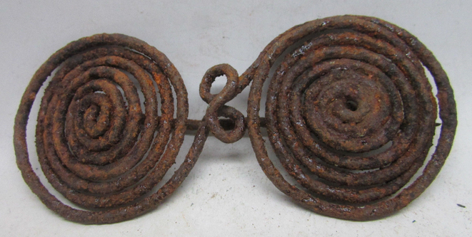 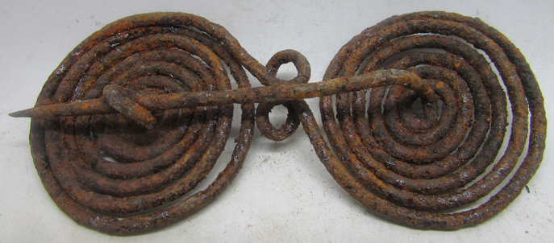

**Case no.: 4**

**Accession Number:**

**Formal Label:** Switzerland-La Tène Celtic Culture-Spectacle Brooch-200-60 BCE

**Display Description: After Wikipedia**

The La Tène culture was a European Iron Age Celtic culture named after the archaeological site of La Tène on the north side of Lake Neuchâtel within Marin-Epagnier's communal boundaries in Switzerland, where the small river Thielle, connects to another lake and enters Lake Neuchâtel. Thousands of objects had been deposited in the lake which were discovered when in 1857, when a prolonged drought lowered the waters of the lake by about 2 m. Hansli Kopp, looking for antiquities for Colonel Frédéric Schwab, discovered several rows of wooden piles that still reached up about 50 cm into the water. From among these, Kopp collected about forty iron swords.

This brooch is composed of two mirror image spirals that can be interpreted as depicting the shadow of the sun described by a gnomon in the summer solstice(clockwise) and the winter solstices (counter clock wise).

**LC Classification:** [GN780.2.L3](http://josiah.brown.edu/search~S7?/c1-SIZE+GN780.2.L3+N38/cgn++780.2+l3+n38/-3%2C-1%2C0%2CE/frameset&FF=cgn++780.2+l3+n38&1%2C1%2C)

**Date or Time Horizon:** 200-60 BCE

**Geographical Area:** north side of Lake Neuchâtel within Marin-Epagnier's communal boundaries in Switzerland

**Map:**

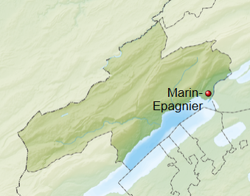

**GPS coordinates:** [47°01′N 7°01′E](https://tools.wmflabs.org/geohack/geohack.php?pagename=Marin-Epagnier&params=47_01_N_7_01_E_region:CH-NE_type:city)

**Cultural Affiliation:** Celtic La Tène culture

**Medium:** Iron

**Dimensions:**

**Weight:**

**Condition: original**

**Provenance:** from the first systematic lowering of the Swiss lakes from 1868 to 1883

**Discussion: After Wikipedia**

With the first systematic lowering of the Swiss lakes from 1868 to 1883, the site fell completely dry. In 1880, Emile Vouga, a teacher from Marin-Epagnier, uncovered the wooden remains of two bridges (designated "Pont Desor" and "Pont Vouga") originally over 100 m long, that crossed the little Thielle River (today a nature reserve) and the remains of five houses on the shore. After Vouga had finished, F. Borel, curator of the Marin museum, began to excavate as well. In 1885 the canton asked the Société d'Histoire of Neuchâtel to continue the excavations, the results of which were published by Vouga in the same year.

The Swiss archaeologist Ferdinand Keller published his findings in 1868 in his influential first report on the Swiss pile dwellings (*Pfahlbaubericht*). In 1863 he interpreted the remains as a Celtic village built on piles. Eduard Desor, a geologist from Neuchâtel, started excavations on the lakeshore soon afterwards. He interpreted the site as an armory, erected on platforms on piles over the lake and later destroyed by enemy action. Another interpretation accounting for the presence of cast iron swords that had not been sharpened, was of a site for ritual depositions.

All in all, over 2500 objects, mainly made from metal, have been excavated in La Tène. Weapons predominate, there being 166 swords (most without traces of wear), 270 lanceheads, and 22 shield bosses, along with 385 brooches (like this one), tools, and parts of chariots. Numerous human and animal bones were found as well. The site was used from the 3rd century, with a peak of activity around 200 BCE and abandonment by about 60 BCE (Megaw and Megaw 2001: 132-133). Interpretations of the site vary. Some scholars believe the bridge was destroyed by high water, while others see it as a place of sacrifice after a successful battle (there are almost no female ornaments).

**References:**

Cunliffe, Barry. 1997. *The Ancient Celts*. Oxford: Oxford University Press. 1997

Collis, John. 2003. *The Celts: Origins, Myths, Invention*. London: Tempus, 2003.

Garrow, Duncan (ed), 2008. *Celtic Art, Reading the Messages*, London: The Everyman Art Library.

James, Simon. 1999. *The Atlantic Celts*. London: British Museum Press.

James, Simon & Rigby, Valery. 1997. *Britain and the Celtic Iron Age*. London: British Museum Press.

Laffon, Robert. 2000. *Les Celtes, histoire et dictionnaire. Des origines à la romanisation et au christianisme.* Paris.

Laing, Lloyd and Jenifer. 1992. *Art of the Celts*, London: Thames and Hudson.

McIntosh, Jane. 2009. *Handbook to Life in Prehistoric Europe*. New York: Oxford University Press.

Megaw, Ruth and Vincent. 1989. *Celtic Art*. London: Thames and Hudson.

Reginelli Servais, Gianna and Béat Arnold, 2007. *La Tène, un site, un mythe*, Hauterive : Laténium - Parc et musée d'archéologie de Neuchâtel. Cahiers d'archéologie romande de la Bibliothèque historique vaudoise, 3 vols.